**Testing Procedures for Base EDA v. 1.0**

**In order to test whether the extension does what we expect and address any strange behavior, we set up a number of fake landscapes with simple community structures and simple ecoregions.**

**STUDY AREA:** The artificial study area is a 10 x 10 km lattice with spatial resolution = 1 ha (100m x 100m).

**ECOREGIONS:** We create two alternative simple spatial arrangements of ecoregions: a single ecoregion for the entire study area (ecoregion1.img) and two horizontal ecoregions of the same size (ecoregions2.img).

 

**ECO2**

**ECO1**

**ECO1**

**10 km**

**10 km**

**INITIAL COMMUNITIES:** We create four equally-sized vertical areas, including a section of inactive pixels, and three with single-species community types (init_comm.img). The rationale behind this is that we want to test whether disease spreads correctly when having the two most important hosts in the pathosystem (e.g. sudden oak death in our case): bay laurel, and oaks (dead ends). To be consistent in each initial community test files, we pick the same age-cohorts for the selected species, trying to include some younger cohorts, medium, and older ones.

We create four alternative simple spatial arrangements of initial community structures:

*init_comm1.txt*:



**10 km**

**10 km**

**Q. agrifolia**

**Q. agrifolia**

**Bay laurel**

**INACTIVE**

*init_comm2.txt*:



**Bay laurel**

**Q. agrifolia**

**Bay laurel**

**INACTIVE**

*init_comm3.txt*:



**Bay laurel**

**Q. agrifolia**

**Bay laurel**

**INACTIVE**

*init_comm4.txt*:



**Q. agrifolia**

**Bay laurel**

**Q. agrifolia**

**INACTIVE**

**INITIAL INFECTIONS:** In order to start our epidemiological extension, we create and use three initial scenarios of starting infections over the artificial landscape, with 1 and 10 infected sites, respectively. Because we want to test the assumption that bay laurel communities drive the spread, while oaks should be dead-ends, we test all combinations of the three scenarios along with the initial community structures described above. The amount of initial infections and their relative distance should influence the speed at which the epidemic spreads. The combinations are the following:

**1 INITIAL INFECTION**

***initEpidem1.img*** *+ init_comm1.txt*:

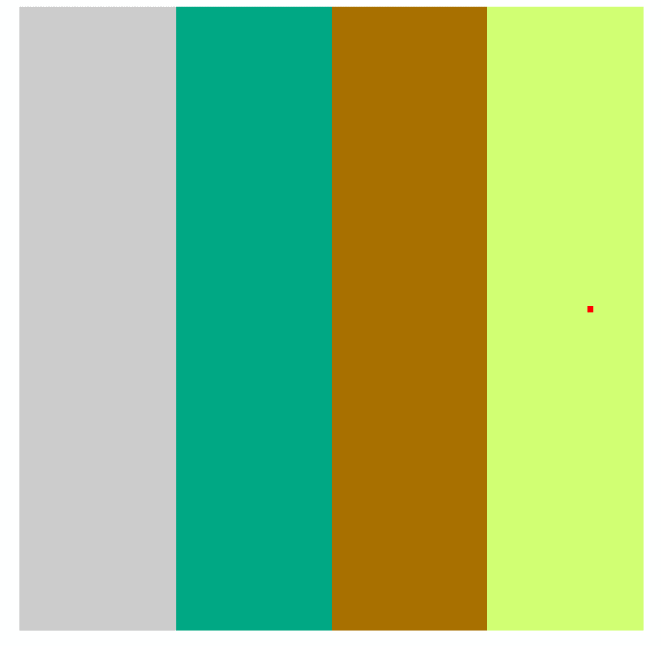

**Q. agrifolia**

**Q. agrifolia**

**Bay laurel**

**INACTIVE**

***initEpidem1.img*** *+ init_comm2.txt*:



**INACTIVE**

**Bay laurel**

**Q. agrifolia**

**Bay laurel**

***initEpidem1.img*** *+ init_comm3.txt*:



**Bay laurel**

**Q. agrifolia**

**INACTIVE**

**Bay laurel**

***initEpidem1.img*** *+ init_comm4.txt*:



**Q. agrifolia**

**Q. agrifolia**

**Bay laurel**

**INACTIVE**

**10 INITIAL INFECTIONS**

***initEpidem10.img*** *+ init_comm1.txt*:

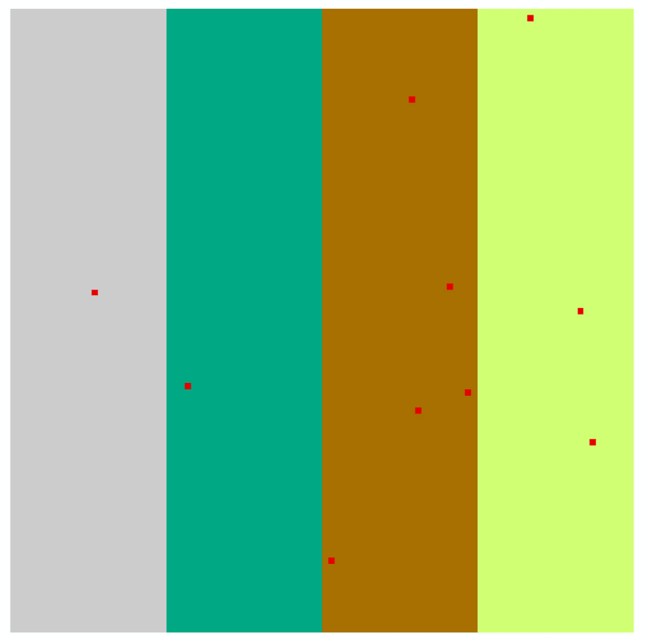

**INACTIVE**

**Bay laurel**

**Q. agrifolia**

**Q. agrifolia**

***initEpidem10.img*** *+ init_comm2.txt*:



**INACTIVE**

**Bay laurel**

**Q. agrifolia**

**Bay laurel**

***initEpidem10.img*** *+ init_comm3.txt*:



**INACTIVE**

**Bay laurel**

**Q. agrifolia**

**Bay laurel**

***initEpidem10.img*** *+ init_comm4.txt*:



**INACTIVE**

**Q. agrifolia**

**Bay laurel**

**Q. agrifolia**